**Practical -1**

**Basic HTML Tags**

1. Create an HTML web page which displays the effects and use of following tags. Also write the importance of each tag with its attributes in comment section.

a. <HTML>

b. <HEAD>

c. <Body>

d. <Title>

e. <i>

f. <b>

g. <u>

h. <p>

i. <pre>

j. <a>

k. <img>

l. <br>

m. <h1>

n. <hr>

o. <sub>

p. <sup>

q. <small>

r. <em>

s. <strong>

t. <mark>

u. <del>

v. <ins>

**HTML CODE**

<!-- Defines Html version 5 -->

**<!DOCTYPE html>**

**<html>**

<!-- The text between <html> and </html> describes an HTML document-->

**<head>**

<!-- it provides information about the HTML document -->

**<title>**Assignment 1 **</title>**

<!-- it provides a title for the HTML -->

**</head>**

**<body>**

<!-- it describes the visible page content-->

**<i>** Convert Text into Italic **</i>**

<!-- it will convert the text into italic -->

**<br>** <!-- tag inserts a single line break. -->

**<b>** This is bold Text **</b>**

<!-- It will convert the text into bold -->

<br>

**<u>** This Is Underline Text **</u>**

<!-- It Will displayed with an underline-->

**<p>** This Is an Paragraph**</p>**

<!-- describes a paragraph -->

**<pre>**

<!-- defines preformatted text-->

******

This

is

Pre-Tag

*********

**</pre>**

**<a href="http://www.google.com">** Hyper Link**</a>**

<!--defines a hyperlink, which is used to link from one page to another.-->

<br>

**<img src="1.png" height="150px" width="150px">**

<!-- it is used to embed an image in an HTML page.-->

**<h1>Heading 1</h1>**  <!-- describes the main heading. -->

**<h2>Heading 2</h2>**

**<h3>Heading 3</h3>**

**<h4>Heading 4</h4>**

**<h5>Heading 5</h5>**

**<h6>Heading 6</h6>**

**<hr** **size=5 color="red**"**>**

<!-- displayed as a horizontal rule that is used to separate content 🡪

H**<sub>**2**</sub>**O

<!-- tag defines subscript text-->

<br>

CO**<sup>**2**</sup>**

<!-- tag defines superscript text. Superscript text appears half a character above the normal line-->

<br>

**<small>** Small Text **</small>**

<!-- tag defines smaller text-->

<br>

**<em>**This is Em Tag**</em>**

<!-- tag is used to define emphasized text.-->

<br>

**<strong>**Strong Tag**</strong>**

<!-- tag is used to define text with strong importance.-->

<br>

**<mark>**This Is Mark Tag **</mark>**

<!-- defines text that should be marked or highlighted.-->

<br>

**<del>**Delete tag**</del>**

<!--defines text that has been deleted from a document. -->

<br>

**<ins>**insert tag**</ins>**

<!--defines a text that has been inserted into a document.---->

**</body>**

**</html>**

*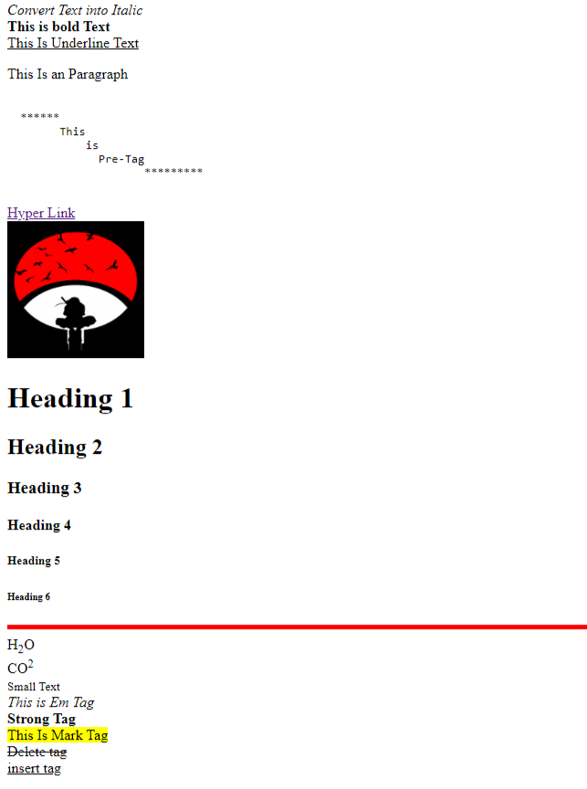****OUTPUT* : -**